**WEEK 01**

**Question 1:**

This is a simple challenge to help you practice printing to stdout.

We're starting out by printing the most famous computing phrase of all time! In the editor below, use either printf or cout to print the string Hello, World! to stdout.

**Input Format**

You do not need to read any input in this challenge.

**Output Format**

Print Hello, World! to stdout.

**Sample Output**

Hello, World!

**Program**

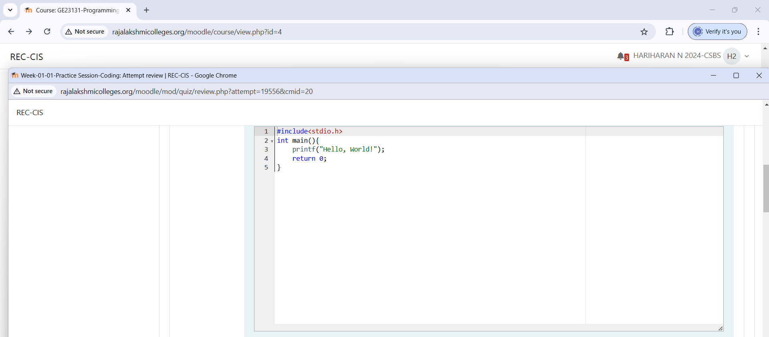

**Output**

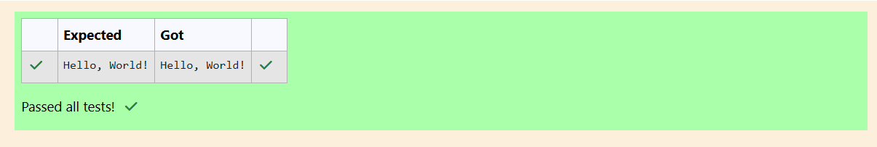

**Question 2:**

This challenge will help you to learn how to take a character, a string and a sentence as input in C. To take a single character ch as input, you can use scanf("%c", &ch); and printf("%c", ch) writes a character specified by the argument char to stdout:

char ch;

scanf("%c", &ch);

printf("%c", ch);

This piece of code prints the character ch. You have to print the character, ch.

**Input Format**

Take a character, ch as input.

**Output**

**Print the character, ch.**

**Program:**

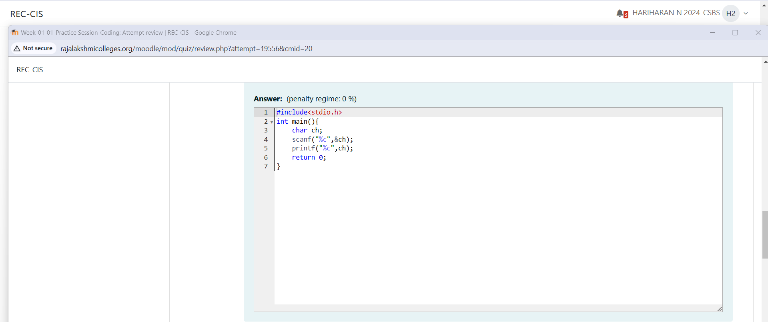

**Output**

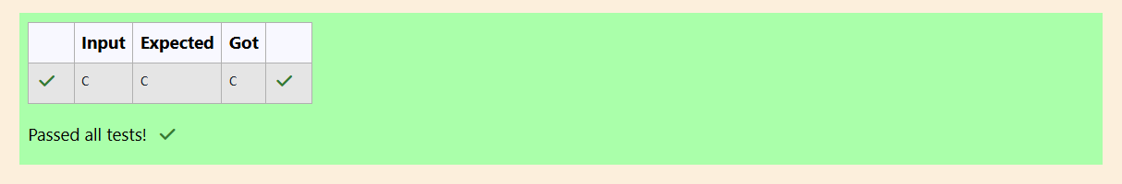

**Question 3:**

Declare 4 variables: two of type int and two of type float. Read 2 lines of input from stdin (according to the sequence given in the 'Input Format' section below) and initialize your 4 variables. Use the + and operator to perform the following operations: Print the sum and difference of two int variable on a new line. Print the sum and difference of two float variable rounded to one decimal place on a new line.

**Input Format:**

The first line contains two integers.The second line contains two floating point numbers.

**Output Format:**

Print the sum and difference of both integers separated by a space on the first line, and the sum and difference of both float (scaled to 1 decimal place) separated by a space on the second line.

**Sample Input:**

10 4

4.0 2.0

**Sample Output**

14 6

6.0 2.0

**Program:**

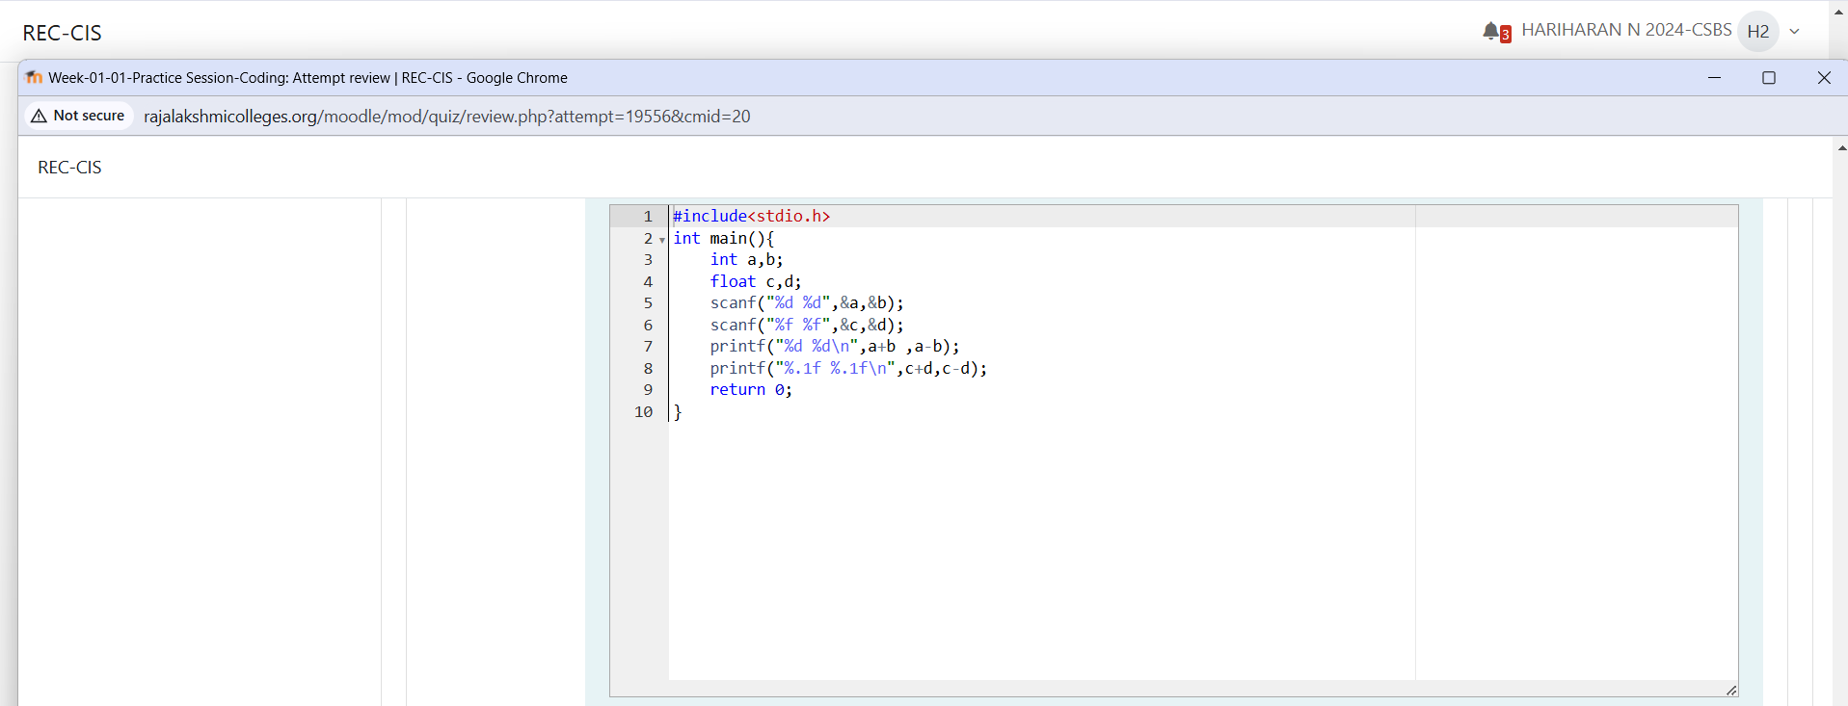

**Output**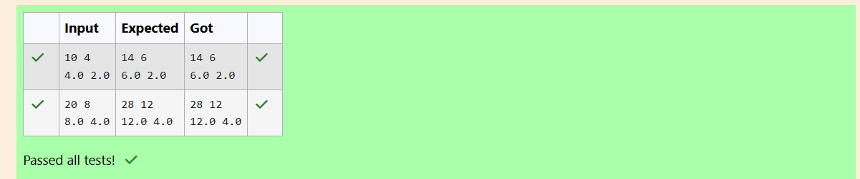

**Question 4:**

Write a program to input a name (as a single character) and marks of three tests as m1, m2, and m3 of a student considering all the three marks have been given in integer format. Now, you need to calculate the average of the given marks and print it along with the name as mentioned in the output format section. All the test marks are in integers and hence calculate the average in integer as well. That is, you need to print the integer part of the average only and neglect the decimal part.

**Input format:**

Line 1: Name(Single character) Line 2: Marks scored in the 3 tests separated by single space.

**Output format:**

First line of output prints the name of the student.

Second line of the output prints the average mark.

**Sample Input 1:**

A

346

**Sample Output 1:**

A

4

**Program:**

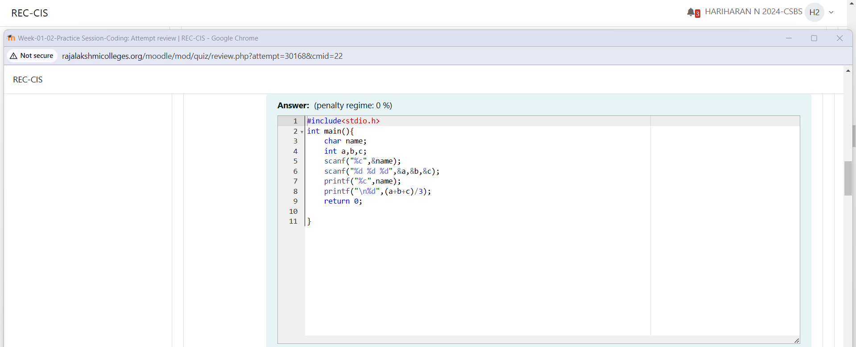

**Output**

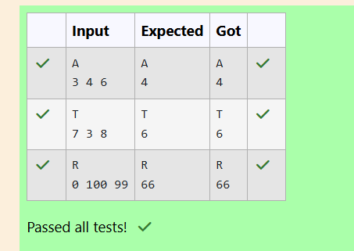

**Question 5:**

To read a data type, use the following syntax: scanf(""format_specifier", &val).

To print a data type, use the following syntax: printf(""format_specifier", val)

**Input Format:**

Input consists of the following space-separated values: int, long, char, float, and double, respectively.

**Output Format:**

Print each element on a new line in the same order it was received as input. Note that the floating point value should be correct up to 3 decimal places and the double to 9 decimal places.

**Program:**

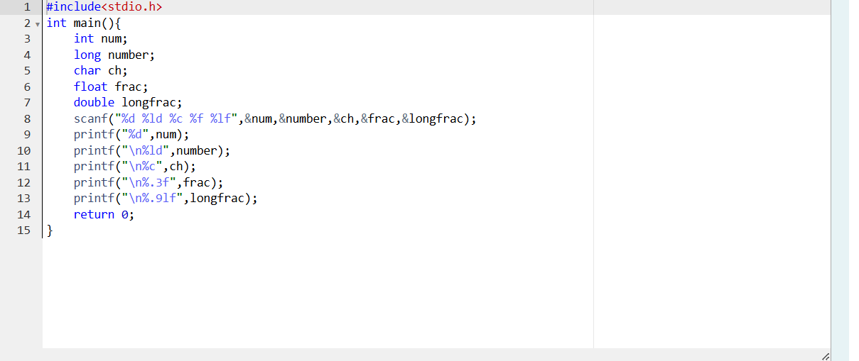

**Output**

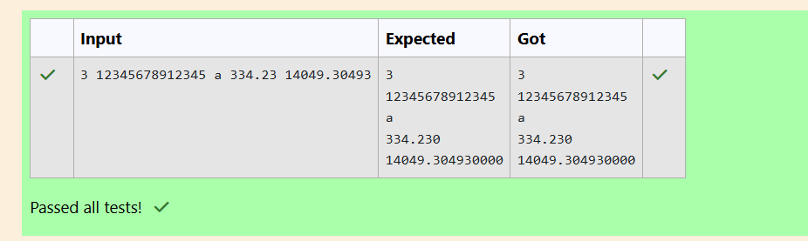

**Question 6:**

Write a program to print the ASCII value and the two adjacent characters of the given character.

**Sample Input:**

E

**Sample Output:**

69

D F

**Program:**

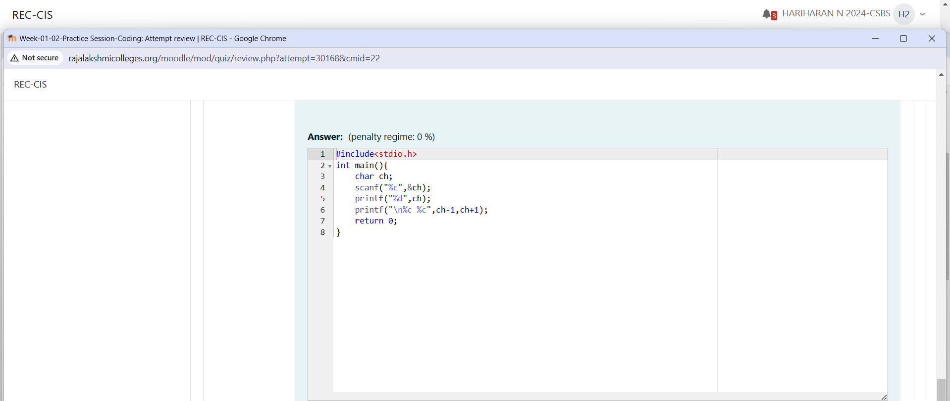

**Output**

